Lab 1
Reza Shisheie
2708062

Part 1: Feature Selection, Cleaning, and Preprocessing to Construct an Input from Data Source

Based on the data I think the following attributes that can affect the results:

- Marital status: Discrete Binary
- Gender: Discrete Binary
- Yearly income: Continuous Interval
- Total Children: Discrete Interval
- Number of children at home: Discrete Interval
- English education: Discrete Ordinal
- House owner flag: Discrete Binary
- number of cars owned: Discrete Interval
- Region: Discrete Nominal
- Age: Discrete Interval

This set of data is not the only ones that may have an effect on the prediction. I am using them as an example. There are other parameters that matter too like commute distance and etc but just for the sake of simplicity and only picking these 10 parameters.

There are a few reasoning behind the parameter selection. I assume (it might be wrong), that women buy bikes more often than men as they might be at home and may need one for fun, and thus gender must be a parameter. I assume couples might be more likely to buy a bike as they may have kids and they need bike. The wealthier you are the easier to buy a bike. The more children you have the more likely to get a bike for your children. If you live in an area with good weather it is likely to own a bike. And the younger you are the more likely to own one.

All these assumptions must be validated but they are parameters based on experience I think are important.

All new data is stored in a new list in python. Here is a comparison of the old and new data set. Original and new attributes with values are listed below:

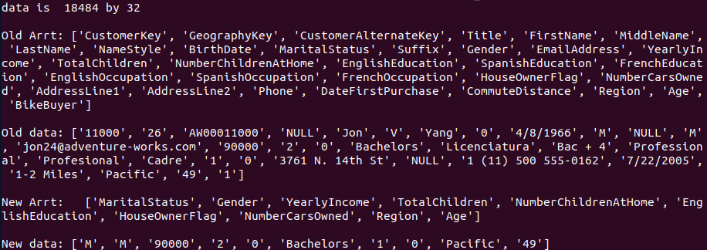
Part 2: Data Preprocessing and Transformation:

All data processing and transformation are listed and explained below:

2.1. Handling Null values and Duplication:
The program goes through all the saved data set and replaces the NULL values with unknown. However, not all null values are valuable. Here is a list of parameters with null values:

Title: 18383
MiddleName: 7830
Suffix: 18481
AddressLine2: 18172

By just looking at the numbers it is evident that most over %98 of data for Title, Suffix, and AddressLine2 are NULL values. It can be deductaed that either it is normal to have null values for these parameters or they are terribly corrupt. We will go throught them one by one:

- Title has to replaced by unknown. It should be Mr, Mrs or niether. As most of them are NULL, and it is just a title probably user did not provide it. In any case this data would not be a source of analysis and is not reliable. All null value titles are replaced by unknown.
- MiddleNames can be replaced by unknown too as some people do not have middle names. However, this might be a fault too. %42 of middle names are null. Middle names are replaced by unknown
- Suffix is replaced by unknown
- AddressLine2 is replaced by unknown

As the null values of all of the parameters mentioned above are more than %10, I assume none of them as a good source of analysis.

After NULL handling, all duplication tuples are recorded. This piece of code captures if there is any duplication. It checks the following parameters:

1. First name
2. Middle name
3. Last name
4. Age

By checking these 4 parameters one should be able to say if there is any duplication if there is no duplicate you may proceed. Otherwise, you may take action and remove the tuple.

There was not duplication found based on the parameters mentioned above.

2.2. Random Sampling :
There is a piece of code in the python script which uses in section 2.2 which performs random sampling. There is not need to implement this section as data is already sampled.
2.3. Mean/Variance/Standard Deviation for Ordinal Numeric attributes

Mean, Mode, Variance, Standard Deviation of ordinal numeric attributes are calculated using separate functions:

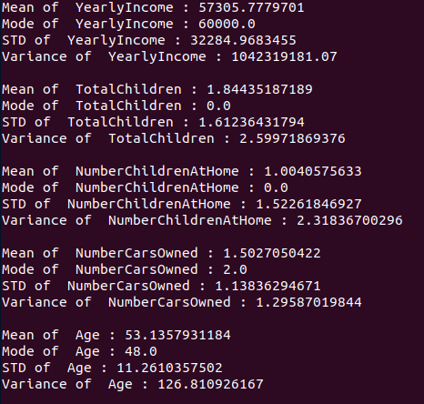

2.4. Normalization :
In this section the non-nominal target data is normalized using min max method. Here is a list of attributes which were normalized:

- YearlyIncome
- TotalChildren
- NumberChildrenAtHome
- NumberCarsOwned
- Age

a function in python named “normalize” is defined for this purpose. Here is a sample data before and after normalization:

As you see only numeric items like salary and number of children are normalized. For instance the value 9000 in the second column which is salary is normalized to 0.5.
2.5. Standardization:
The normalized data is standardized using z-score method. A function called “z-score” is defined for this purpose. The following set is selected for standardization followed by the number of bins assigned to each one:

- YearlyIncome 10
- TotalChildren 6
- NumberChildrenAtHome 6
- NumberCarsOwned 5
- Age 15

Number of bins for each attribute is selected experimentally and were increased based on the type of data and consistency of result after changing bins. For instance the maximum value for the number of children was 5 and min 0 so I found 6 bins as the best option.

Here is data before and after standardization:

2.6. Discretization and Histogram
The same bin numbers were used to plot histogram data. Here is data in histogram:
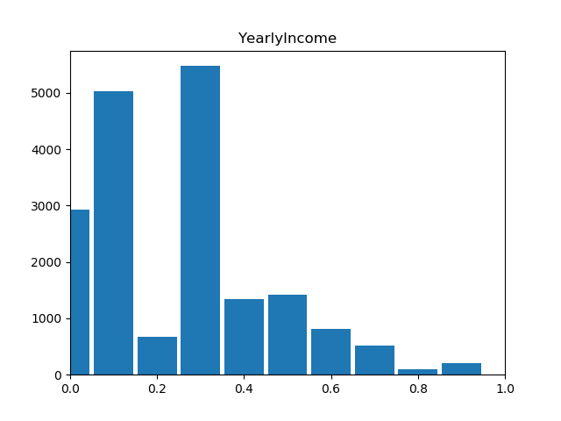
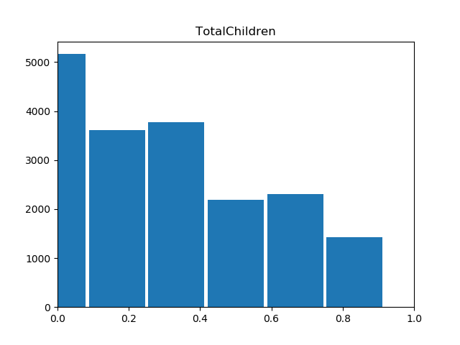
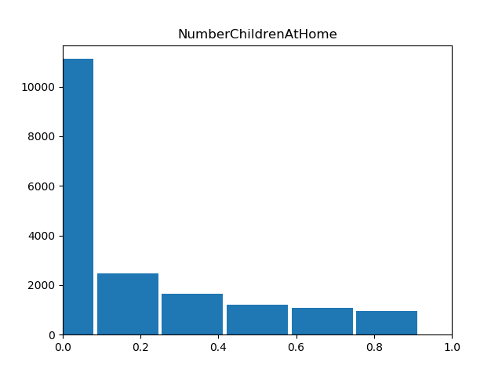
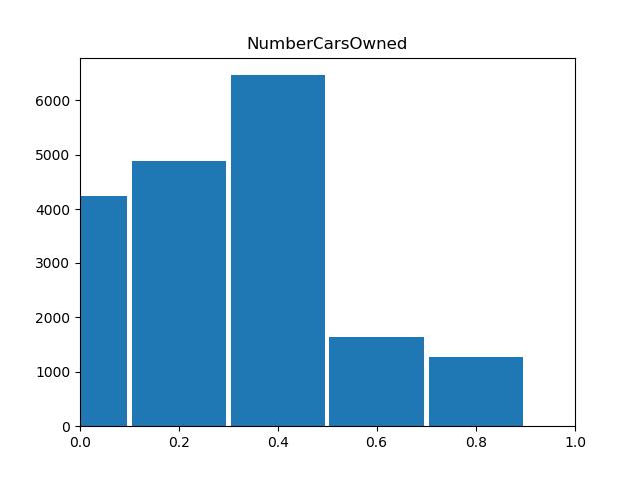
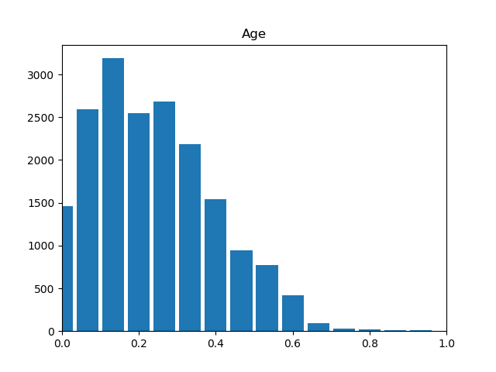

2.7. Get Median of the Grouped data:
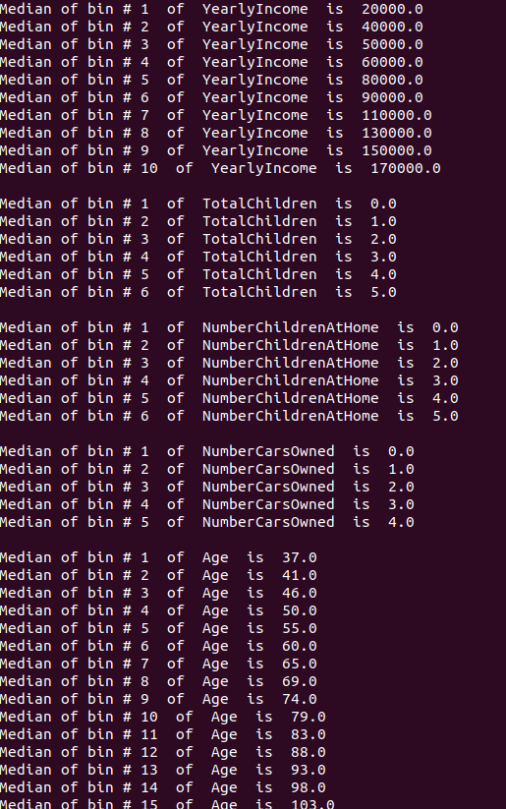
2.8. Binarization
in this section all the nominal values were binerized. Here is the list of nominal values which were binerized:

- Marital status
- Gender
- English education
- House owner flag
- Region:

Here s data at 0 and 300 before and after binerization:

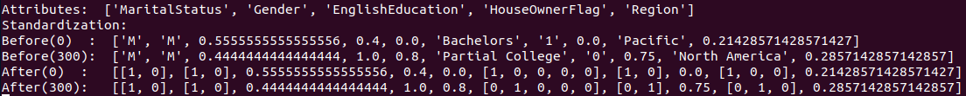

As you can see different number are assigned to Pacific (100) and North America (101)

Part 3: Calculating Proximity of Two Binary Object Vectors

3.1. Similarities of 11000 and 11001:

3.2. Similarities of 11000 and 11002

The conclusion from similarity is that (11000 , 11012) are more similar than (11000 , 11001)
CODE

"""
game prediction project 0

"""
import csv
import matplotlib.pyplot as plt
import numpy as np
from scipy import stats
import math

def normalize(target, data):

#target = 'YearlyIncome'
targetCol = 0
for j in range(0,Y):
if header[j] == target:
targetCol = j

maxTar = 0
minTar = 9999999
for i in range(0,X):
if int(data[i][targetCol])<minTar:
minTar = int(data[i][targetCol])
if int(data[i][targetCol])>maxTar:
maxTar = int(data[i][targetCol])

for i in range(0,X):
data[i][targetCol] = (float(data[i][targetCol])-float(minTar))/(float(maxTar) - float(minTar))
# data[i][targetCol] = float(data[i][targetCol])

return data

def mean(target, data, header):

targetCol = 0
for j in range(0,Y):
if header[j] == target:
targetCol = j

targetArray = []
for i in range(0,X):
targetArray.append(data[i][targetCol])

meanVal = np.array(targetArray).astype(np.float)
meanVal = np.mean(meanVal)
print 'Mean of ', target, ':', meanVal
return meanVal

def mode(target, data, header):

targetCol = 0
for j in range(0,Y):
if header[j] == target:
targetCol = j

targetArray = []
for i in range(0,X):
targetArray.append(data[i][targetCol])

modeVal = np.array(targetArray).astype(np.float)
modeVal = stats.mode(modeVal)
print 'Mode of ', target, ':', modeVal[0][0]
return modeVal[0][0]

def standardDev(target, data, header):

targetCol = 0
for j in range(0,Y):
if header[j] == target:
targetCol = j

targetArray = []
for i in range(0,X):
targetArray.append(data[i][targetCol])

stdVal = np.array(targetArray).astype(np.float)
stdVal = np.std(stdVal)
print 'STD of ', target, ':', stdVal
return stdVal

def variance(target, data, header):

targetCol = 0
for j in range(0,Y):
if header[j] == target:
targetCol = j

targetArray = []
for i in range(0,X):
targetArray.append(data[i][targetCol])

varVal = np.array(targetArray).astype(np.float)
varVal = np.var(varVal)
print 'Variance of ', target, ':', varVal
print ''
return varVal

def zScore(data, header, numData, binLen):
#print data[1]
for i in range(0,len(data)):
binCount = 0
for j in range(0,len(data[0])):
if header[j] in numData:
r = math.floor(data[i][j]/(1.0/binLen[binCount]))+1
if data[i][j]==1:
r = math.floor(data[i][j]/(1.0/binLen[binCount]))
z = (r-1)/(binLen[binCount]-1)
data[i][j] = z
binCount = binCount + 1

return data

def histogramPrint(data, header, numData, binLen):
dataSet = []
for j in range(0,len(data[0])):
temp = []
if header[j] in numData:
for i in range(0,len(data)):
temp.append(data[i][j])

dataSet.append(temp)
#print binLen, len(binLen)
#print numData, len(numData)
#raw_input()
#'''

for i in range(0, len(numData)):
numDSet = i
#hist, bin_edges = np.histogram(dataSet[numDSet], bins = 'auto')
hist, bin_edges = np.histogram(dataSet[numDSet], binLen[i])
#wid = math.floor((max(dataSet[numDSet]) - min(dataSet[numDSet]))/len(bin_edges))
#wid = ((max(dataSet[numDSet]) - min(dataSet[numDSet]))/len(bin_edges))
#wid = 0.09
wid = (1.0/binLen[i])-0.01
plt.bar(bin_edges[:-1], hist, width = wid)
plt.xlim(min(bin_edges), max(bin_edges))
plt.title(numData[i])
plt.show()
#'''

def binerize(header, headerB, data):
variableList = []
for j in range(0,len(data[0])):
if header[j] in headerB:
temp = []
for i in range(0,len(data)):
if data[i][j] not in temp:
temp.append(data[i][j])
variableList.append(temp)

#
#print variableList
#print headerB
#selec = 300
#print data[selec]

for i in range(0,len(data)):
count = 0
for j in range(0,len(data[0])):
if header[j] in headerB:
temp = []
for jj in range(0, len(variableList[count])):
#print ' ', data[i][j] , variableList[count][jj]
if data[i][j] == variableList[count][jj]:
temp.append(1)
else:
temp.append(0)
#print temp
#raw_input()
data[i][j] = temp
count=count+1

#print ''
#print data[selec]
#print header[2]

def binMedian(data, header, numData, binLen, dataOrg):
dataSort = []
dataSortOrg = []
#print len(data)

#print dataOrg[0]
#raw_input()

#tempOrg = map(int, tempOrg)

for j in range(0,len(data[0])):
temp = []
tempOrg = []
if header[j] in numData:
for i in range(0,len(data)):
temp.append(data[i][j])
tempOrg.append(float(dataOrg[i][j]))
temp.sort()
tempOrg.sort()
dataSort.append(temp)
dataSortOrg.append(tempOrg)
#print tempOrg
#raw_input()

#print len(dataSort), len(dataSort[0])
#print dataSortOrg[0]
#print len(dataSort), len(dataSort[0])
#print len(dataSortOrg), len(dataSortOrg[0])
#print (dataSort[0][0])
#print (dataSortOrg[0][0])

for i in range(0,len(dataSort)):
count = 1
dx = 1.0/binLen[i]
temp = []
for j in range(0,len(dataSort[0])):
temp.append(dataSortOrg[i][j])
if dataSort[i][j]>count*dx:

med = int(math.floor(len(temp)/2))
#print count*dx
#print len(temp), med, float(temp[med])
print "Median of bin #", count, " of ", numData[i], " is ", temp[med]
#print np.mean(temp)
#raw_input()
count = count + 1
#print ''
#print temp
#print ''
#raw_input()
temp = []

med = int(math.floor(len(temp)/2))
#print temp[0], med
print "Median of bin #", count, " of ", numData[i], " is ", temp[med]
print ''
#print temp
#print ''
#raw_input()

def simData(data,dataType, dataTarget):

c1 = 0
c2 = 2

print 'DataSet 11000 :', data[c1]
print 'DataSet 11012 :', data[c2]

#print data[c1]
#print data[c2]
simArray = []
distance = []
for i in range(0,len(dataType)):
if dataType[i] == 'b':
cell1 = data[c1][i]
cell2 = data[c2][i]
temp = 0
for j in range(0,len(data[0][i])):
#print cell1[j], cell2[j]
if cell1[j] == cell2[j]:
temp = temp + 1
#print temp, len(data[0][i])
temp = 1.0*temp/len(data[0][i])
#print temp
#print ''
else:

temp = abs(data[c1][i] - data[c2][i])
#print data[c1][i] , data[c2][i]
#print ' ' , temp

distance.append(temp)

#print data[c1][i], data[c2][i], temp

hamming = sum(distance)*1.0/len(data[0])
print 'hamming: ', hamming

simArray = []
distance = []
for i in range(0,len(dataType)):
if dataType[i] == 'b':
cell1 = data[c1][i]
cell2 = data[c2][i]
temp = 0
countZero = 0
for j in range(0,len(data[0][i])):
#print cell1[j], cell2[j]
if cell1[j] == cell2[j] and cell1[j] == 1 :
temp = temp + 1
if cell1[j] == cell2[j] and cell1[j] == 0 :
countZero = countZero + 1
#print temp, len(data[0][i])
temp = 1.0*temp/(len(data[0][i])-countZero)
#print temp
#print ''
else:

temp = abs(data[c1][i] - data[c2][i])
#print data[c1][i] , data[c2][i]
#print ' ' , temp

distance.append(temp)

#print data[c1][i], data[c2][i], temp

jaccard = sum(distance)*1.0/len(data[0])
print 'jaccard: ', jaccard

simArray1 = []
simArray2 = []
distance = []
A = 0
B = 0
B1 = 0
B2 = 0
for i in range(0,len(dataType)):
if dataType[i] == 'b':

cell1 = data[c1][i]
cell2 = data[c2][i]
tempA = 0
tempB1 = 0
tempB2 = 0
for j in range(0,len(data[0][i])):
if cell1[j] == 1 and cell2[j]==1:
tempA = tempA + 1
if cell1[j] == 1:
tempB1 = tempB1 + 1
if cell2[j] == 1:
tempB2 = tempB2 + 1

A = A + tempA
B1 = B1 + tempB1*tempB1
B2 = B2 + tempB2*tempB2

else:

A = A + data[c1][i]*data[c2][i]
B1 = B1 + data[c1][i]*data[c1][i]
B2 = B2 + data[c2][i]*data[c2][i]

cosine = 1.0*A/(math.sqrt(B1)*math.sqrt(B2))
print 'cosine: ', cosine

###############################################################
###############################################################

plat = []
data = []
with open('vTargetMailCustomer.csv', 'rb') as f:
reader = csv.reader(f)
for row in reader:
data.append(row)
if row [16] not in plat and row [16]!='EnglishEducation':
plat.append(row [16])

header = data.pop(0)

#print header
X = len(data) # number of tuples
Y = len(data[0]) # number of attributes

print "data is ", X, "by", Y
print ''
print 'Old Arrt:', header
print ''
print 'Old data:', data[0]
print ''

####################
'''
PART 1.

here is alist of all atributes and its type. I will gather all these data in
a new data matrix:

1. Marital status: Discrete Binary
2. Gender: Discrete Binary
3. Yearly income: Continuous Interval
4. Total Children: Discrete Interval
5. Number of children at home: Discrete Interval
6. English education: Discrete Ordinal
7. House owner flag: Discrete Binary
8. number of cars owned: Discrete Interval
10. Region: Discrete Nominal
11. Age: Discrete Interval

At the enf of this section header holds all target atributes and data holds
tuple data
'''
header1 = ['MaritalStatus','Gender', 'YearlyIncome', 'TotalChildren', 'NumberChildrenAtHome', 'EnglishEducation', 'HouseOwnerFlag', 'NumberCarsOwned', 'Region', 'Age']
data1 = []

for i in range(0,X):
row = []
for j in range(0,Y):
if header[j] in header1:
row.append(data[i][j])
data1.append(row)

X = len(data1) # number of tuples
Y = len(data1[0]) # number of attributes

data = []
#dataOrg = []

for i in range(0,X):
row = []
for j in range(0,Y):
row.append(data1[i][j])
data.append(row)
# dataOrg.append(row)

print 'New Arrt: ', header1
print ''
print 'New data:', data[0]
raw_input()

header = []
for i in range(0,len(header1)):
header.append(header1[i])

from copy import deepcopy
dataOrg = deepcopy(data)

####################
'''
PART 2.1:
handling null values:

all values that are null are replaced by unknown however, not
all null values are valuable. Here is a list of parameters with
null values:
Title: 18383
MiddleName: 7830
Suffix: 18481
AddressLine2: 18172

By just looking at the numbers it is evident that most over %98 of data
for Title, Suffix, and AddressLine2 are NULL values. It can be deductaed
that either it is normal to have null values for these parameters or they
are terribly corrupt. We will go throught them one by one:

1. Title has to replaced by unknown. It should be Mr, Mrs or niether. As
most of them are NULL, and it is just a title probably user did not provide
it. In any case this data would not be a source of analysis and is not
reliable. All null value titles are replaced by unknown.
2. MiddleNames can be replaced by unknown too as some people do not have
middle names. However, this might be a fault too. %42 of middle names are
null. Middle names are replaced by unknown
3. Suffix is replaced by unknown
4. AddressLine2 is replaced by unknown

As the null values of all of the parameters mentioned above are more than %10,
I assume none of them as a good source of analysis.

'''

count = 0
for j in range(0,Y):
count = 0
for i in range(0,X):
#if data[i][j] == '':
if data[i][j] == 'NULL':
count = count + 1
data[i][j] = 'unknown'
#print count , " : ", header[j]

####################
'''
PART 2.1:
duplication:

This pice of code captures if there is any duplications. It checks the following
parameters:
1. First name
2. Middle name
3. Last name
4. Age

By checking these 4 parameters one shoudl be able to say if there is any duplication
if there is no duplicate you may proceed. Ottherwise, you may take action and remove
the tuple.

'''
'''
for i in range(0,X):
for j in range(0,X):
if i != j:
if data[i][4] == data[j][4] and data[i][5] == data[j][5] and data[i][6] == data[j][6] and data[i][30] == data[j][30]:
print i, j , "duplicate", data[i][4], data[i][5], data[i][6], data[j][4], data[j][5], data[j][6]

'''
####################
'''
PART 2.2:
Random sampling:

This set of data is already sampled so there is not need to sample. In care
there is a need to random sample data you can use the following piece of code

'''
'''
import random
import math
sampleData = []
sampleNum = 100
for i in range(0,sampleNum):
randomData = random.uniform(0, 1)
randomData = int(math.floor(randomData*X))
sampleData.append(randomData)

print sampleData
'''

####################
'''
PART 2.3: Mean/Variance/Standard Deviation for Ordinal Numeric attributes
'''
print 'Mean, Mode, Variance, Standard Deviation:'
numData = ['YearlyIncome', 'TotalChildren', 'NumberChildrenAtHome', 'NumberCarsOwned', 'Age']
meanData = []
modeData = []
STDData = []
varData = []
for i in range(0,len(numData)):
meanData.append(mean(numData[i], data, header))
modeData.append(mode(numData[i], data, header))
STDData.append(standardDev(numData[i], data, header))
varData.append(variance(numData[i], data, header))

raw_input()

####################
'''
PART 2.4: Normalization
In this section data is normalized

'''
#print 'Attributes:', dataOrg[0]
print 'Normalization:'
print 'Before: ' , data[0]

data = normalize('YearlyIncome',data)
data = normalize('TotalChildren',data)
data = normalize('NumberChildrenAtHome',data)
data = normalize('NumberCarsOwned',data)
data = normalize('Age',data)

print 'After :' , data[0]
print ''
raw_input()

####################
'''
PART 2.5: Standardization
calculating z-score
'''
binLen = [10, 6, 6, 5, 15]
print 'Standardization: '
print 'Before: ' , data[0]
data = zScore(data, header, numData, binLen)
print 'After: ', data[0]
raw_input()

####################
'''
PART 2.6: Discretization: Histogram
calculating bins and plotting histogram
'''

#histogramPrint(data, header, numData, binLen)

####################
'''
PART 2.7: Getting median of bins
'''

binMedian(data, header, numData, binLen, dataOrg)
raw_input()

####################
'''
PART 2.8: Binerization

1. Marital status: Discrete Binary
2. Gender: Discrete Binary
3. Yearly income: Continuous Interval
4. Total Children: Discrete Interval
5. Number of children at home: Discrete Interval
6. English education: Discrete Ordinal
7. House owner flag: Discrete Binary
8. number of cars owned: Discrete Interval
10. Region: Discrete Nominal
11. Age: Discrete Interval

'''
headerB = ['MaritalStatus', 'Gender', 'EnglishEducation', 'HouseOwnerFlag', 'Region']
print 'Attributes: ', headerB
print 'Standardization: '
print 'Before(0) : ', data[0]
print 'Before(300): ', data[300]

binerize(header, headerB, data)
#print data[0]
print 'After(0) : ', data[0]
print 'After(300): ', data[300]
print ''
raw_input()

####################
'''
PART 3: Similarity

'''

dataType = ['b', 'b','n','n','n','b','b','n','b','n']
dataTarget = [0,1]
#print len(data[0])
#print data[0]
#print data[1]

simData(data,dataType, dataTarget)

